Guide of Easy-Use

Catalogue
Products and components………………………………………………1
Start to use……………………………………………………………..1
Installment of hardware……………………………………………….2
Installation and use of mobile App ……………………………………3
Installation of video camera……………………………………………6
Setting of Wi-Fi network……………………………………………..11
Point-to-point mode......……………………….……………………...13
FAQ……………………………………..…..………………………..14

Products and components
- Camera
- Power adapter
- Installation stent
- Guide for quick start
- Disc

Start to use
Install hardware

Connect to AP of camera

Add camera

Obtain real time video, peer-to-peer use
配置摄像机Wifi信息

Need to connect router

Allocate camera WiFi

Close AP in camera, Watch under WiFi
Installation of mobile App
1. Download and install BVCam, download IOS in iphone store, search for Android system in GooglePlay. For convenience of installation, please scan the below two-dimension code to download BVCam installation. If your device can not be connected to GooglePlay, please scan the below APK two-dimension code for installation. Note: it is suggested to use the QR code Scanner self-contained by browser or from the third party to scan and download App, while direct downloading and installation of App file is not supported by the function of WeChat scanning.



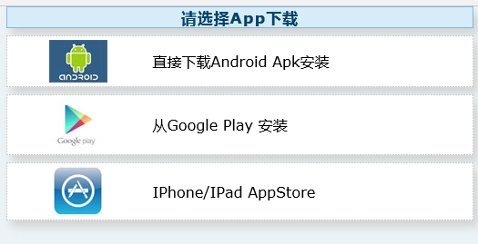
2. Clik “+” to add a new camera. Clik and add the networked camera to enter into the added page of camera, fill out UID or add camera. Note: when the camera is initially used, please set camera to connect with your router referring to the part “setting camera to connect WIFI network”in the instructions, then add camera
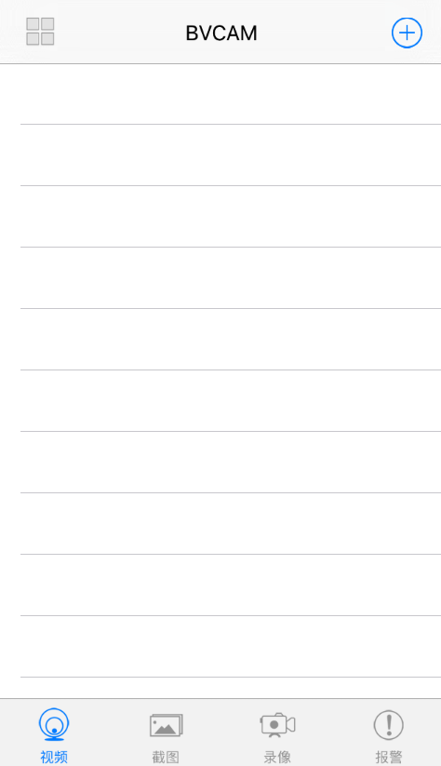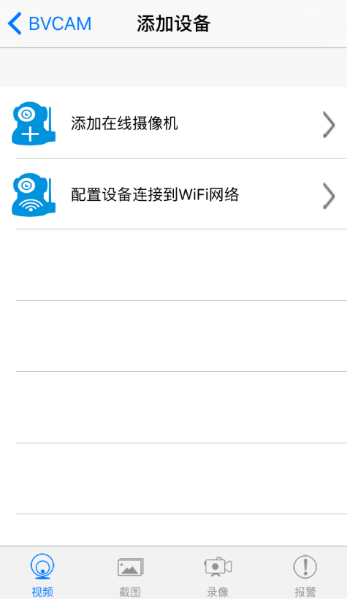

3. Two methods for fast input of UID for camera: A, by scanning of two-dimensional code in camera, B, by searching camera in local area network.

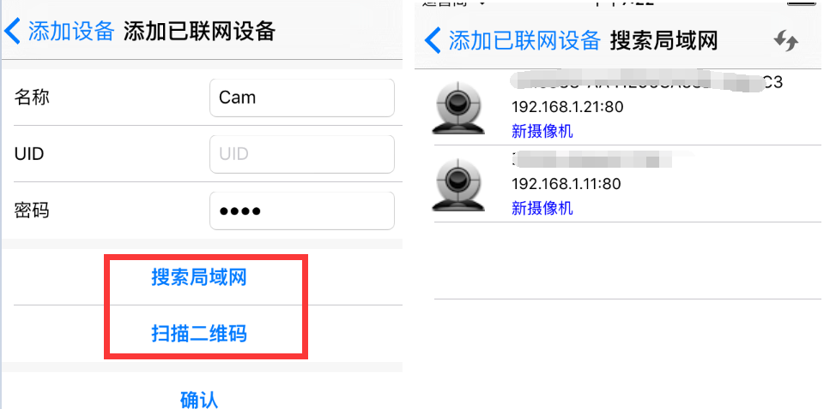
Name

UID
Password

New camera
New camera
Add device, add networked device

4. Filling in the name of camera and password of P2P . Default P2P password: 8888, click OK if confirmed. Successfully add camera. You are suggested to revise P2P visiting password for camera after camera is set.
Name

UID
Password

Add device, add networked device

5. After displayed that camera is online, click camera which you just add to watch real time video, click at video interface, you can open the control disc of video.

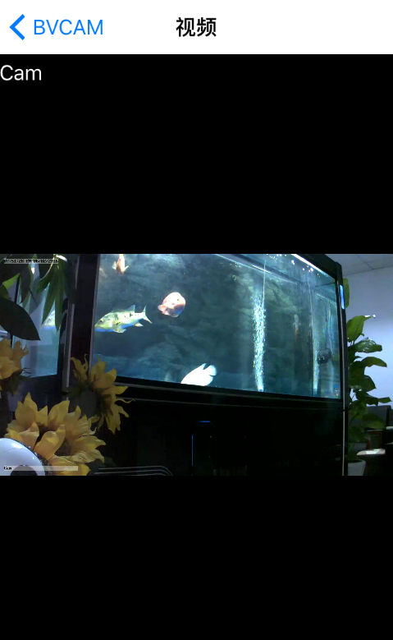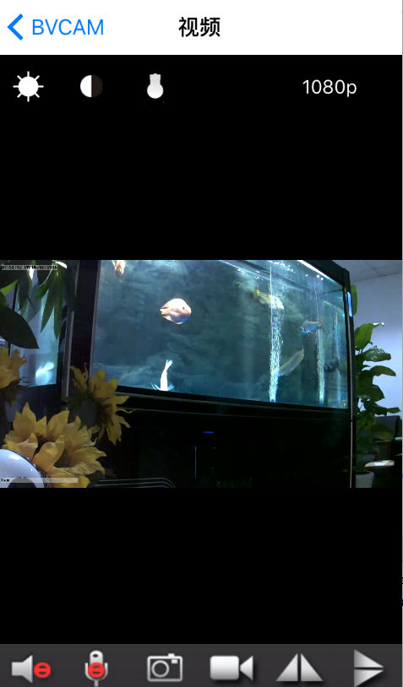

6. The icon and button of the pages in video

PTZ control | Slide your fingers up and down, left or right on the video page, and you can control camera cradle head rotation, and the distance of cradle head rotation depends on the distance of your finger-sliding (need to be supported by the camera purchased)
 | Allow the user to listen to the voice of camera and two-way voice intercom (need to be supported by the camera purchased)
 | take snapshot and record video file
 | level of cradle head and vertical cruise (need to be supported by the camera purchased)
 | images of horizontal and vertical turnover
 | adjust brightness and contrast

- Other functions on the pages

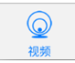  Video | Watch current real time video pictures
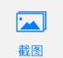  Screenshot | Check screenshot taken by the camera
  Videotape | Check the recording file in your mobile device
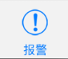  Alarming | Check the record of alarming events in the camera

Set the camera

1. Long press the list item for about three second or click the gear-like button to open the advanced configuration page of the camera.

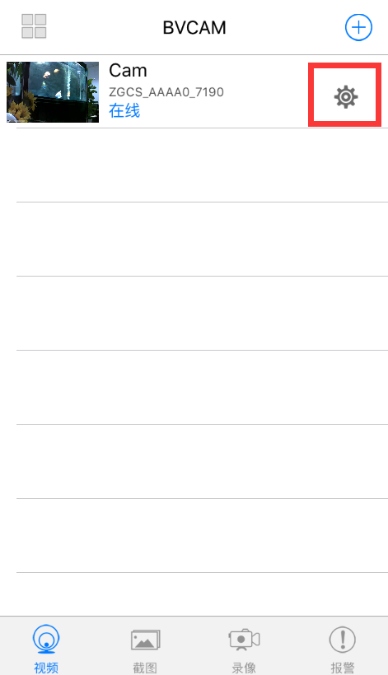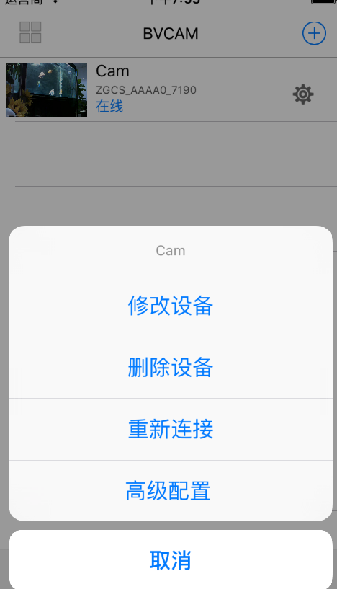
Video Screenshot Video recording Alarm

2. Change the WIFI connection of the camera. Select “WIFI connection configuration”, the camera will display available Wi-Fi hotspot. Select the name of your Wi-Fi (SSID), enter the passwords of Wi-Fi, and then press “OK” to connect Wi-Fi. Note: after saving, if the camera has connected with WIFI, it will switch off the current connection and try to connect the new WIFI network, so that in App, the camera will be off-line temporarily for about 1 minute.
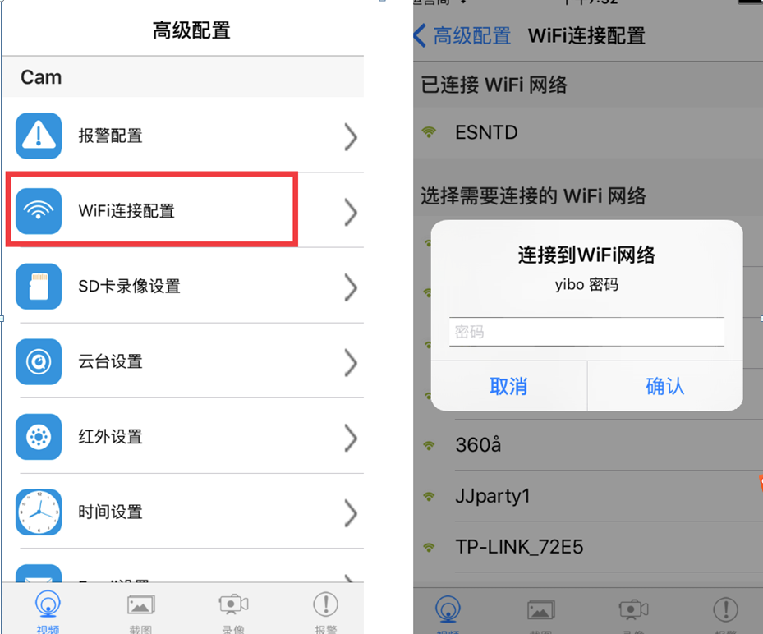
4. SD card video-recording setting: set the mode of SD card video-recording and the frame size.
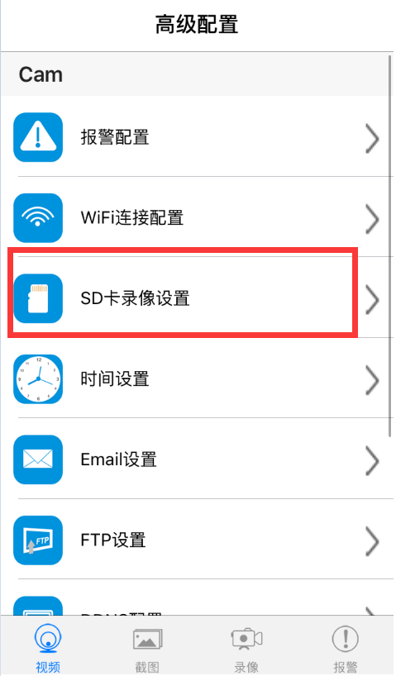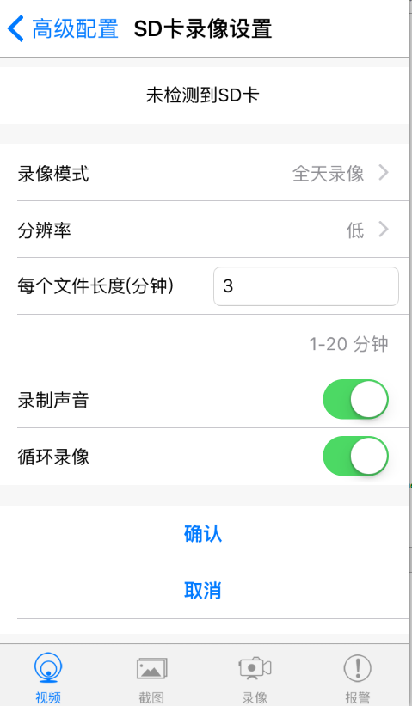
5. Alarm configuration: Turn on or off motion detection alarm and set the interval time of alarm.

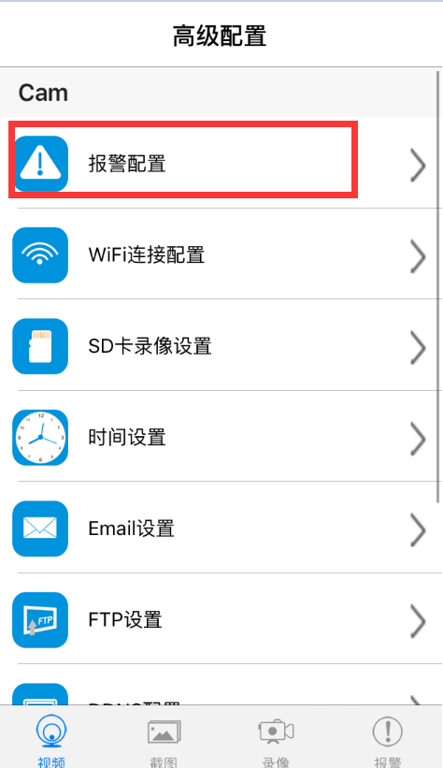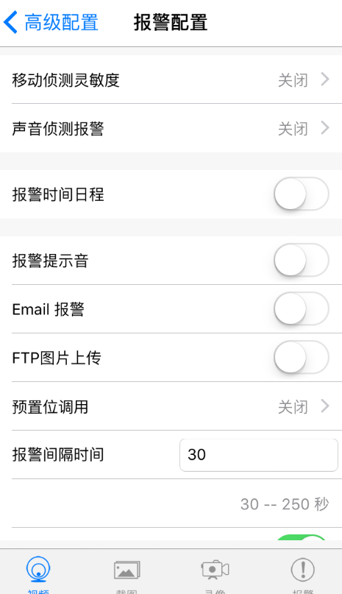

Connect the camera with Wi-Fi network
In case of a new camera or in case that your camera is installed at a new location, please reset the camera to factory settings (after the camera starts, press and hold the reset button for more than 5 seconds), AP mode is on after the camera is restarted, wifi indicator flashes slowly (every 3 seconds). And then open the setting of phone, connect the phone with AP hotspot of camera (WIFI network is named as camera UID), turn on APP until the phone is switched to WIFI network of camera.
- Connect the phone with AP hotspot of camera (WIFI network is named as camera UID), turn on APP until the phone is switched to WIFI network of camera
- Choose “Add camera +” in App
- Chose “connect the camera with WIFI network
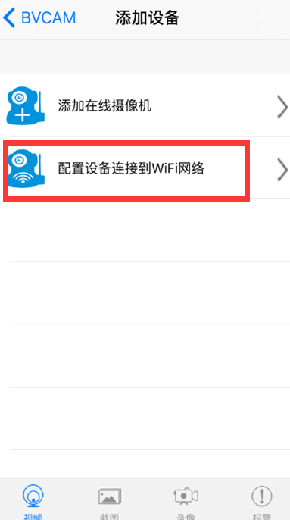
Add device

Video Screenshot Video recording Alarm
4. Scan QR code of camera UID, click “next”, and then confirm that the name of WIFI network displayed is right, enter the correct WIFI passwords and click “Start” to configure Wi-Fi.
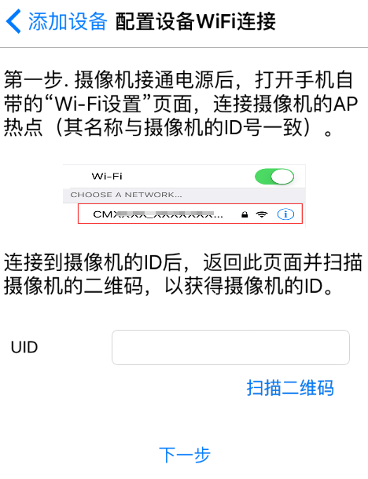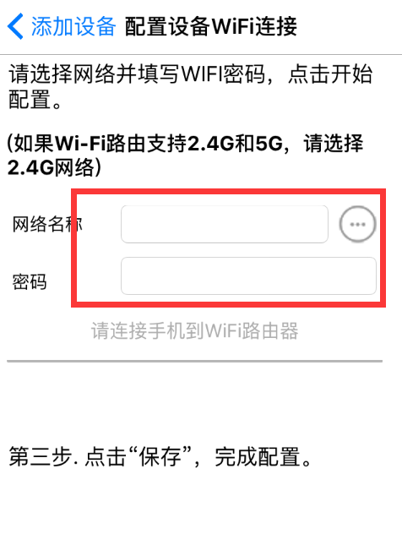

5. Wait until App prompts that Wi-Fi connection settings are completed and the camera is online, click “add a new camera” to add a camera

Notes: if APP always display failure, please check the following items:
A. Before starting to configure Wifi, the indicator of camera does not flash slowly, AP is not turned on
B. The phone does not connect with AP of the camera, and it is necessary for configuration to connect your phone with AP hotspot of the camera
C. Support common router but do not support public router for which login page authentication is needed.
D. During configuration, check whether the network name, passwords and UID are right.
E. In current, Chinese Wifi name and passwords are not supported.
F Do not support 5G Wifi signal
G. Check whether Wifi indicator is always on, if yes, the camera is connected with the network, please directly add online camera, App may not detect that the camera is successfully configured due to network mask.
H. If WiFi is in WEP encryption mode, please change it to WPA mode.

Watch a video in point-to-point mode

In case that there is no a Wifi router, you can directly watch a view and operate the camera in point-to-point mode.

Steps:
1. Reset the camera, turn on AP mode until the camera restarts,
2. After starting the camera, find Wifi configuration page in your phone with the name same as Wifi network of camera UID, without passwords, which is not encrypted.
3. Connect your phone with the Wifi network, wait for Wifi signal symbol which suggests that your phone is successfully connected.
4 Slimmer to router mode, directly add online camera, and then it can be used normally. If the camera has been added, it can be added directly.
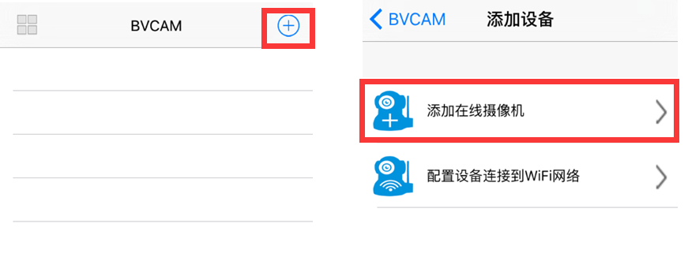
5. Open and watch a video after successful connection.
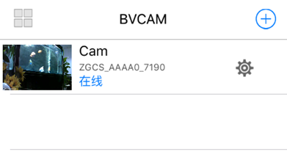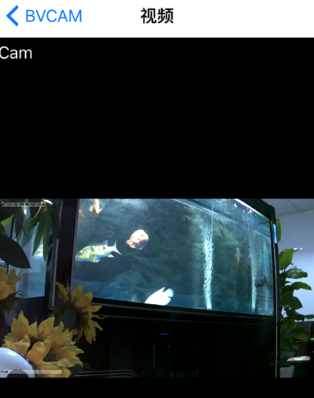

FAQ
1. Why the search tool cannot find the camera?
Answer: Please confirm that the network is normal, close the firewall and security software, ensure that the camera is connected with the router.

2. Why the camera always ask for the user name and passwords, in other words, the use name is not right?
Answer: The default passwords are 8888, if you forget the user name or passwords, you can reset the camera to factory settings to gain the default user and passwords.

3. How can I recover the camera to the factory settings?
Answer: Please press and hold the Reset button for about 5 seconds until the camera restarts.

4. Why the image is not clear?
Answer: Please remove the protective file of lens, if the question is not solved, please rotate the lens for focusing, and then the image will be clear.

